**Class Hierarchy Diagrams**

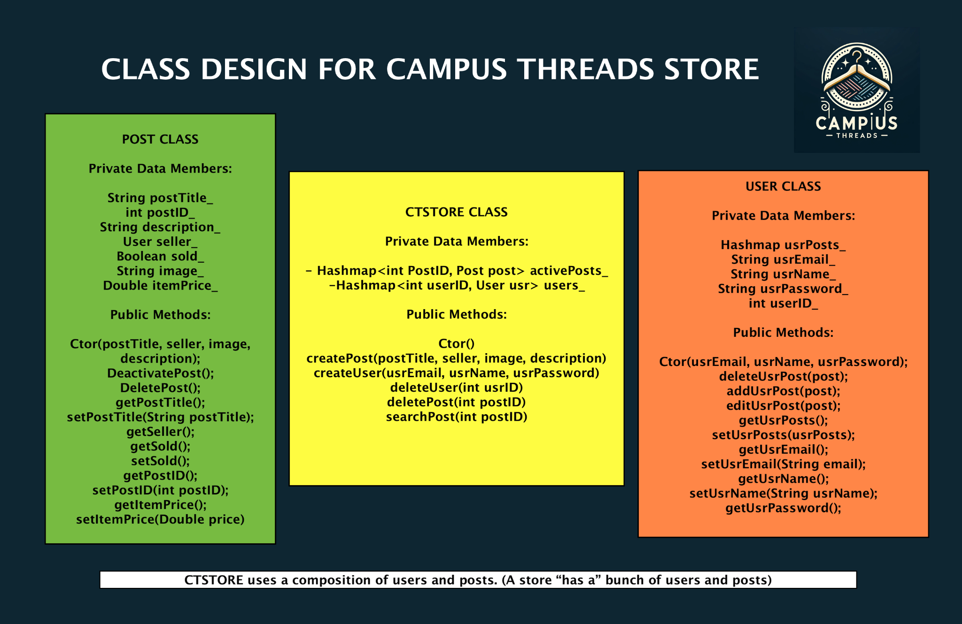

**Software Requirements**

* We will be using HTML/CSS/JavaScript for the frontend to serve our store web pages
* We will be using Java and Spring Boot to develop our API

**Backend Tasks**

* We will need to create our REST API routes that will handle CRUD operations related to USER information

/getAllUsers

* Params: none
* Returns all users from database

/getAllPosts

* Params: none
* Returns all posts from database

/getUser

* Params: userName
* Return a specific user

/getPost

* Params: Post
* Return a specific post

/updateUser

* Params: userName, User
* Updates a specific user with new information

/updatePost

* Params: Post Object
* Updates information related to the specific Post

/deletePost

* Params: Username
* Deletes specific Post

/deleteUser

* Params: Username
* Deletes specific user

/login

* Params: username, password
* Returns true if the username and password are valid
* Returns false and error message if incorrect

/register

* Params: userName, email, password
* Create a User

/postPost

* Params: Post, UserName
* Posts the Post to database

/postUser

* Params: User
* Posts the user to the database

**Frontend Tasks**

* Login Page
  + Design the username, password, guest registration, user registration, and login button/textboxes
* Home Page
  + Create a row of cards that contain information about products and allow users to interact with them (ie. clicking them)
* Profile Page
  + Display user details and user postings (in the same manner as home page)
* Create Posting Page
  + Allow users to fill in details about their listing (price field, category field, images field, short description field, contact information field, and name field) through textboxes and a “create” button.

**MySQL Database**

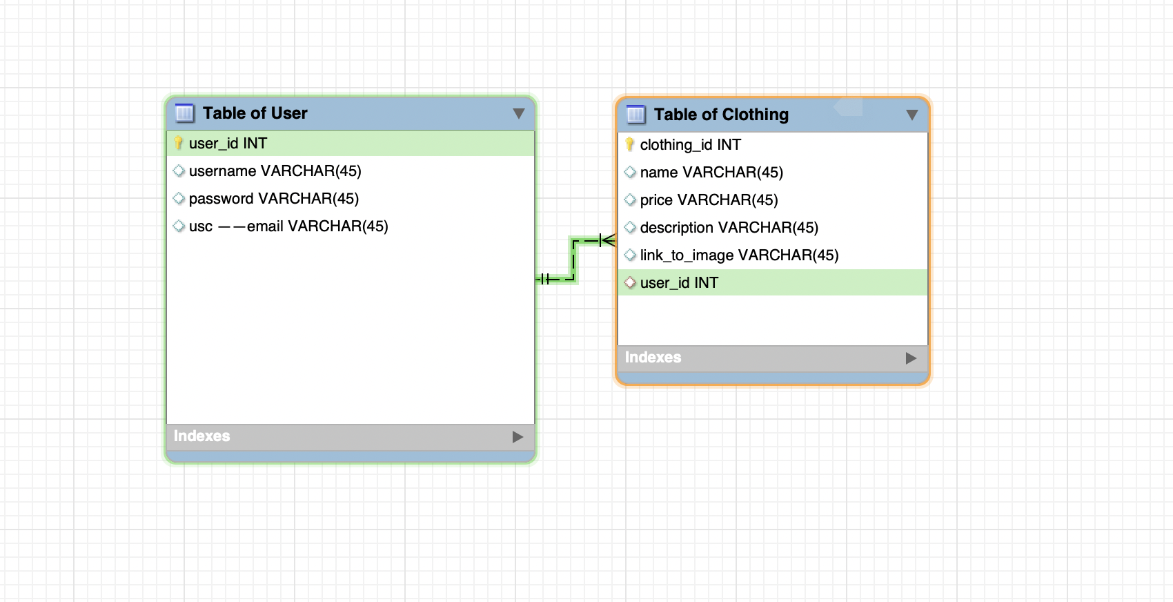

Methods of storing images (prefer 1, 2 is a backup option):

1. Store them in a cloud file system and store the URL of them in the database.
2. Store them directly inside the database as a BLOB (Binary Large Object), decode them when outputting.

**GUI Concept:**

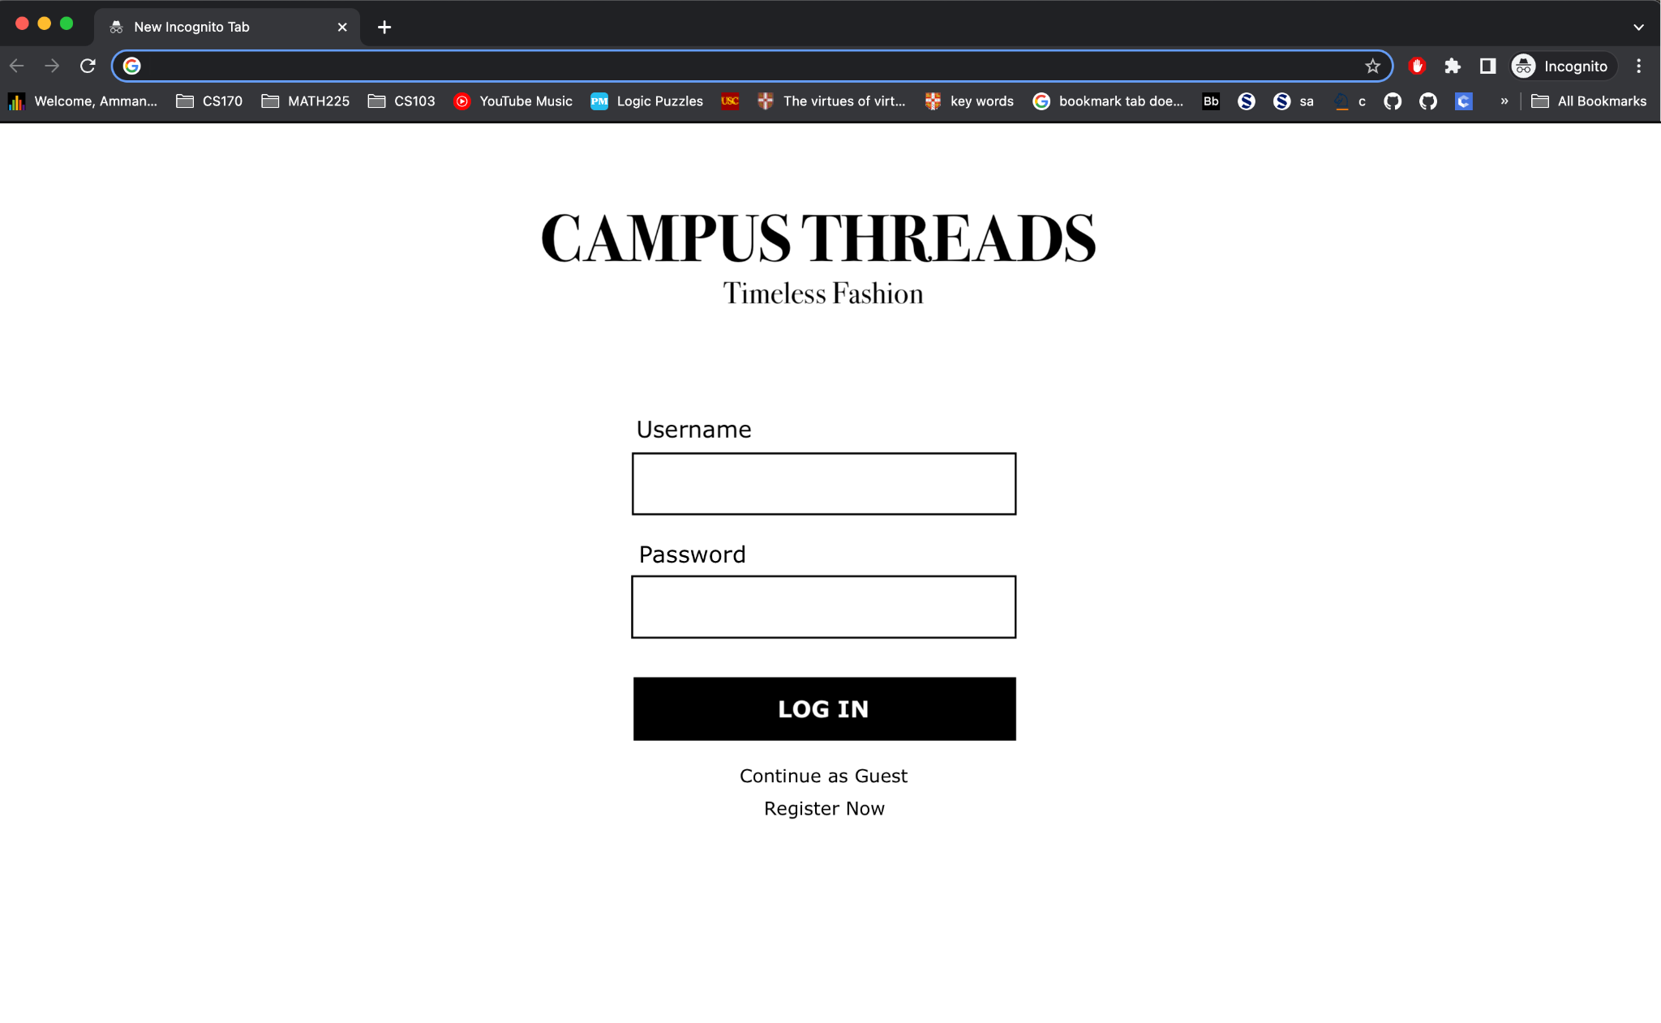

**Log In Page / Register Page**

Log In (for Registered Users)

Register Now (to become a Registered User).

Register Now (to become a Registered User).

Continue as Guest (buy only access).

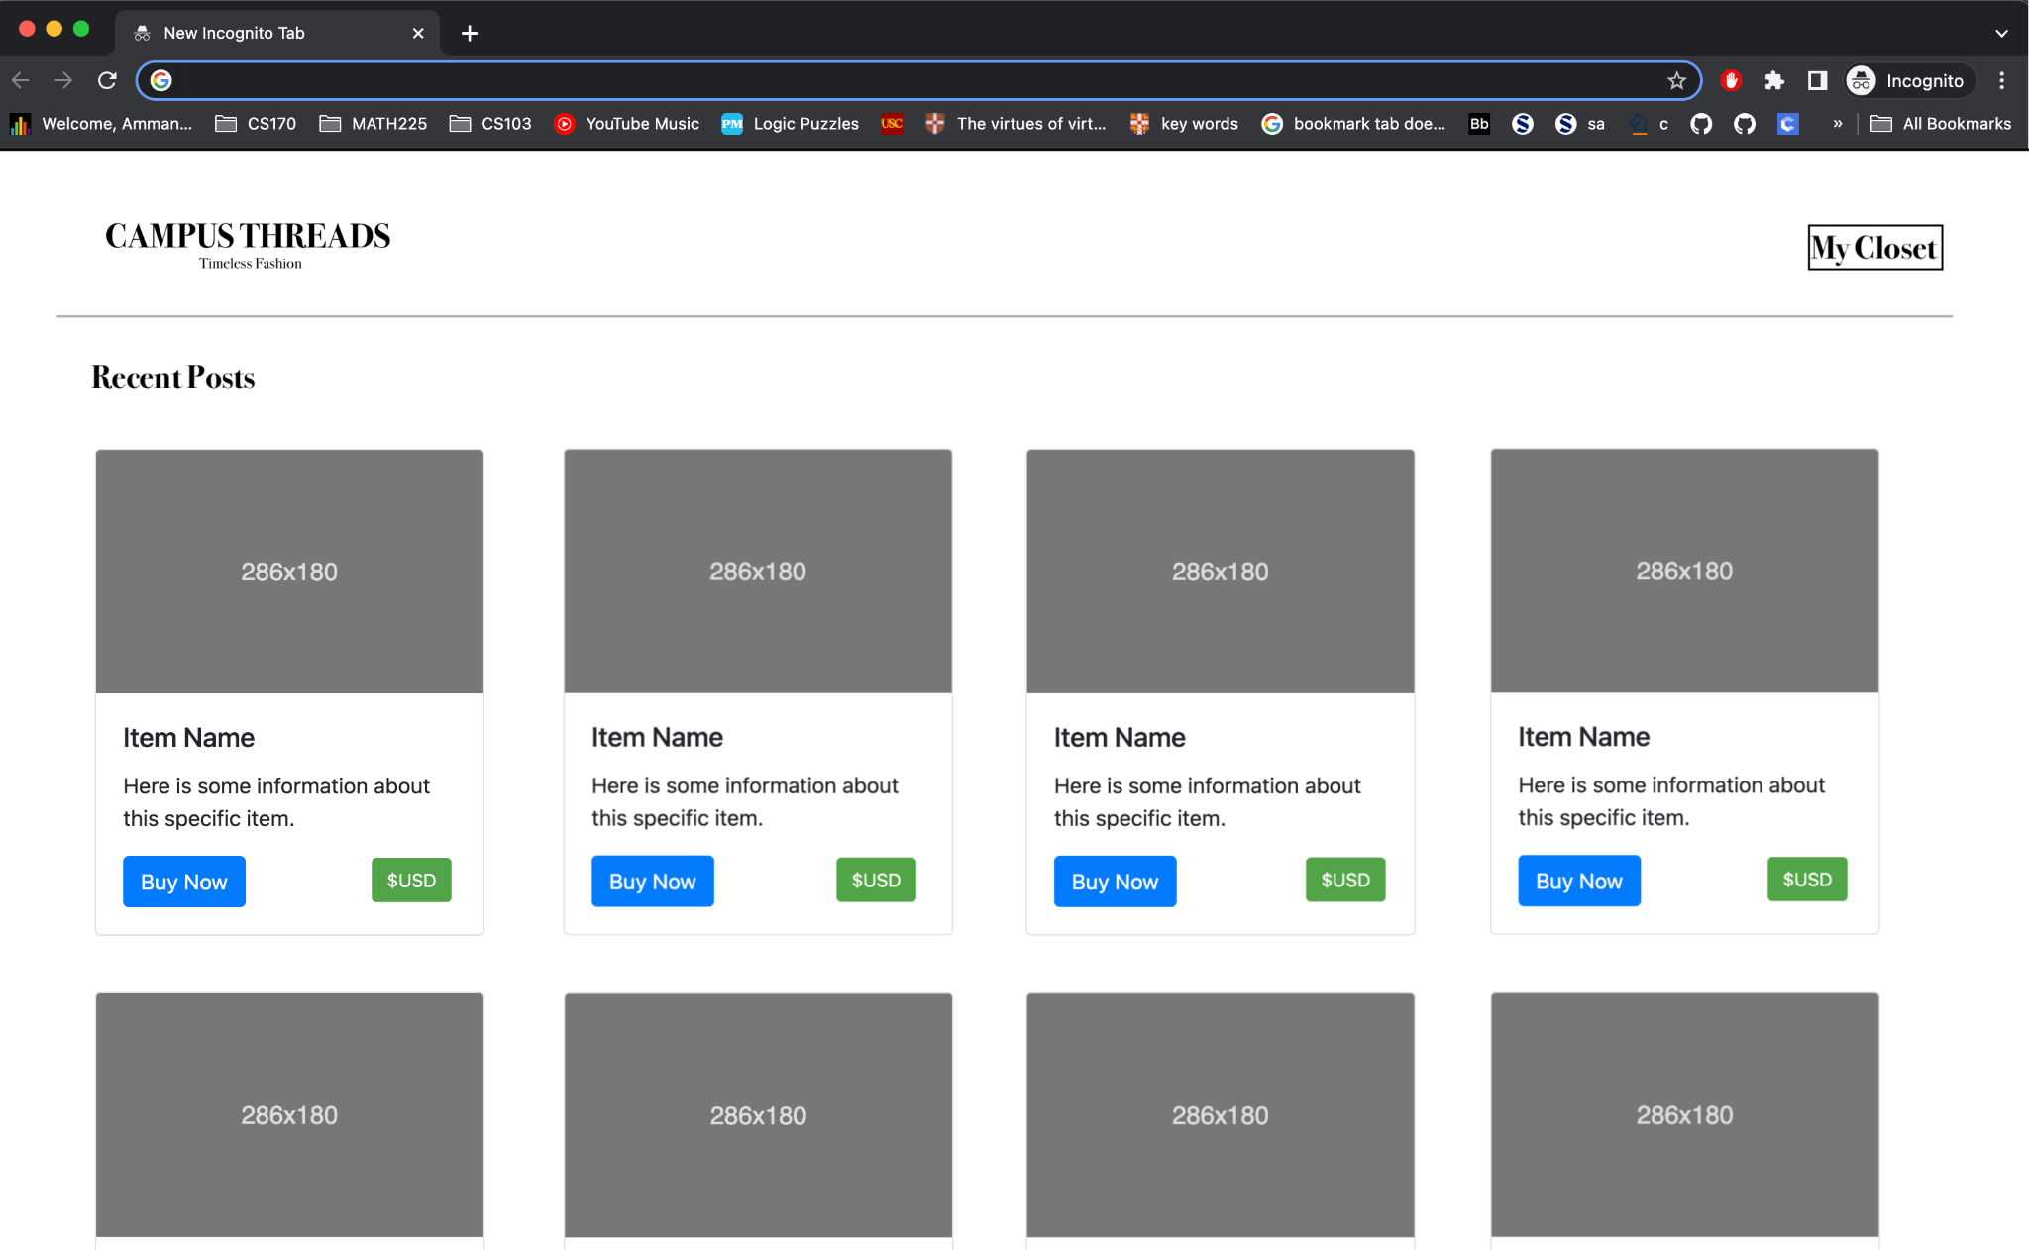

**Home Page**

View Posts from other registered users.

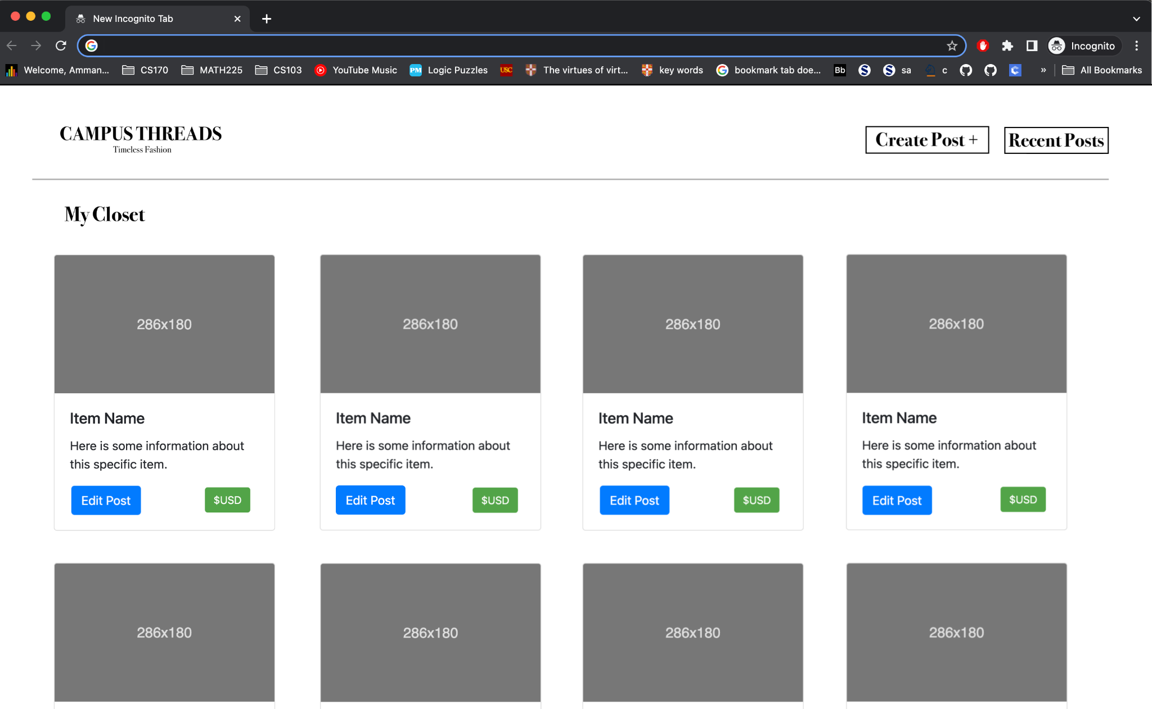

**Registered User Dashboard**

View your own posts.

Update posts if need be.

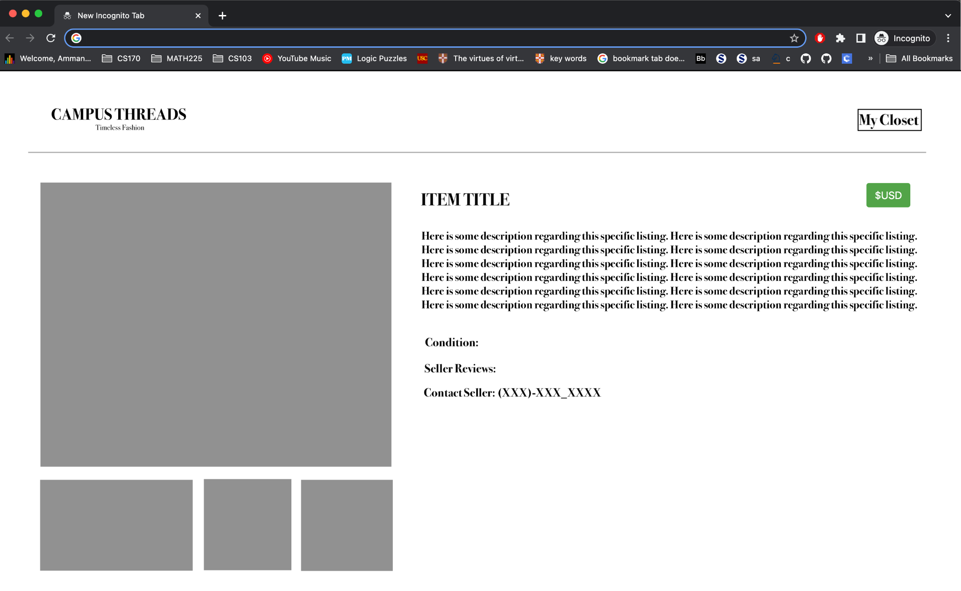

**Buy Now Page**

Provides item specific information.

Connects seller with buyer to facilitate purchase.